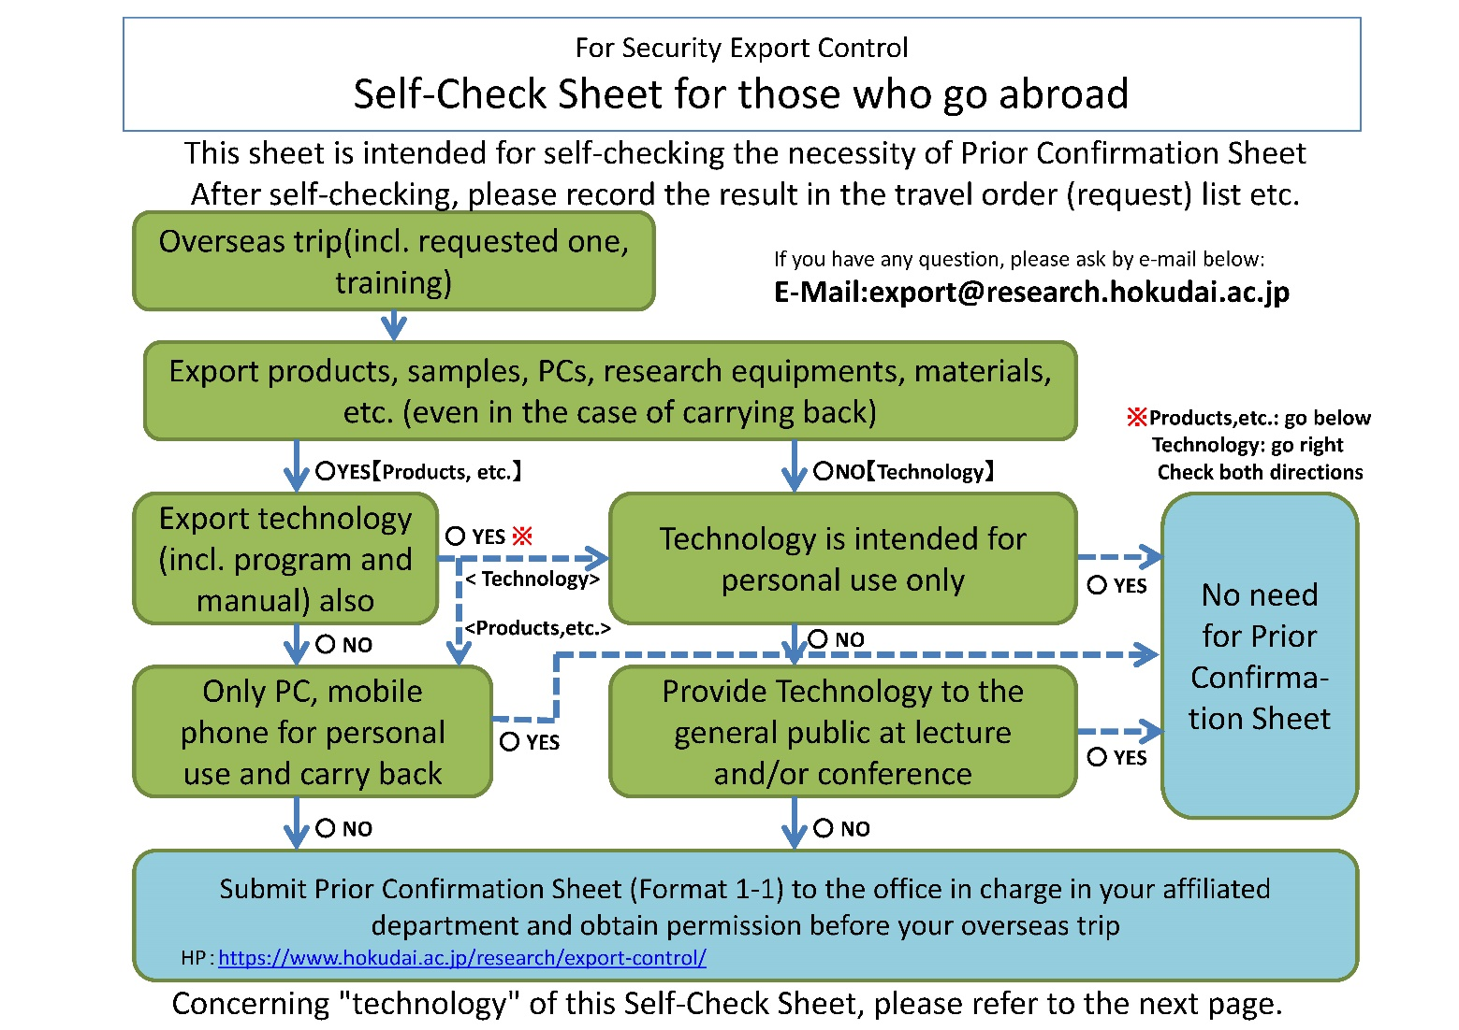
【One program for Global Goals】
As a result of checking the above Self-Check Sheet for Foreign Business Trips, etc. for Security Export Controls and Laws and Regulations, this business trip (period: , 202 , to 202 / Place: ) is

☐Not applicable

☐I have submitted Pre-confirmation sheet (Form 1-1) and obtained permission.

year month day

Affiliation/occupation
Name

